**NAAN MUDHALVAN**

**ASSIGNMENT DOCUMENT**

**COURSE TITLE** : DIGITAL MARKETING

**COLLEGE CODE** : 1105

**COLLEGE NAME** : GOJAN SCHOOL OF BUSINESS AND TECHNOLOGY

**NM ID** : 6ED7F8EC46A776BA0744A80A5DBE9BA1

**NAME** : ROKESH V

**REGISTER NUMBER** : 110520106015

**YEAR** : 4TH YEAR

**DEPARTMENT** : ELECTRONICS AND COMMUNICATION ENGINEERING

1. Create a blog or website using Blogspot and Wordpress. Customize the theme design and post new article with 500 words.

Link: https://dhanushownbranch.blogspot.com/2023/10/galaxy-juice-shop.html

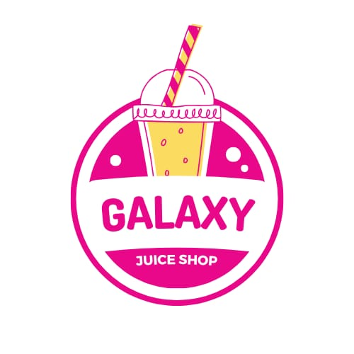

2.Create a New Facebook Business Page and post one social media poster for your brand.

Link: <https://www.facebook.com/galaxy.juice.shop?mibextid=ZbWKwL>

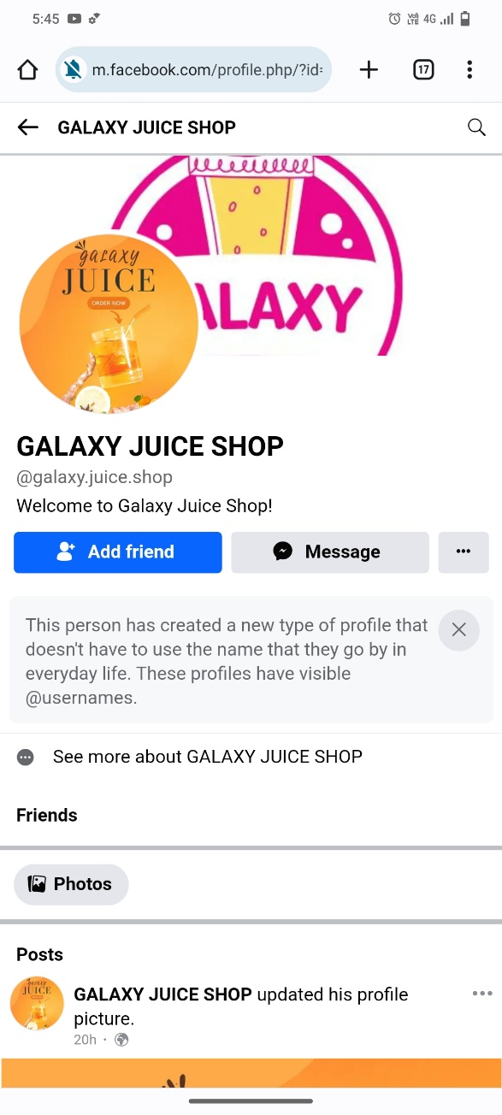

3.Create and design a social media advertisement poster using canva.

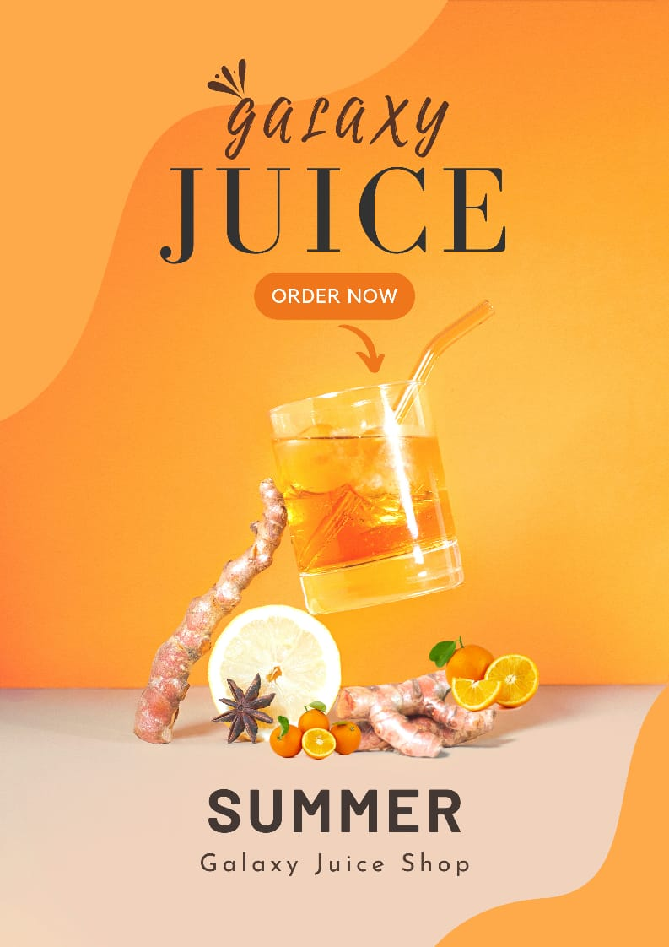

4.Create email newsletter design using MailChimp or canva tool.

Link: <https://dhanushownbranch.blogspot.com/2023/10/galaxy-juice-shop_22.html>

